CSE 473: Homework Assignment 3

# **Tejas Vyas**

1. Description of the Implementation:

Input Images: 2 images view1.png and view5.png from the given folders.

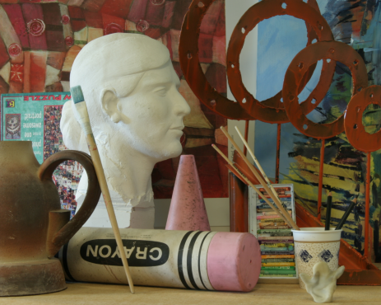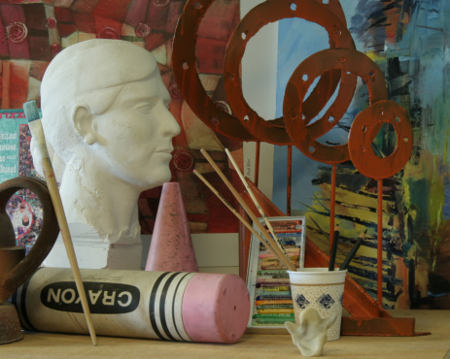

The Disparity Maps obtained after running the images are as follows:

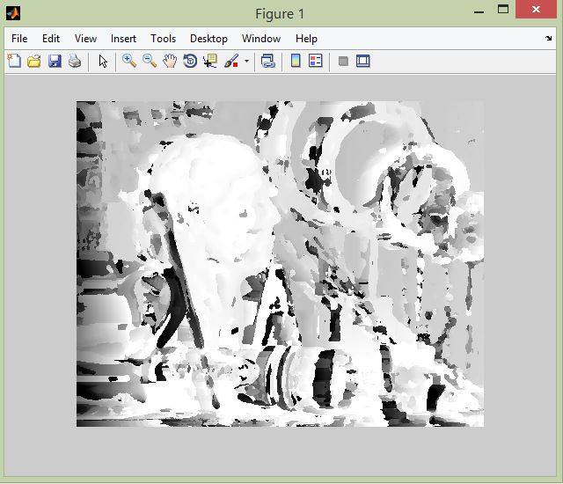 **For Left to Right image**

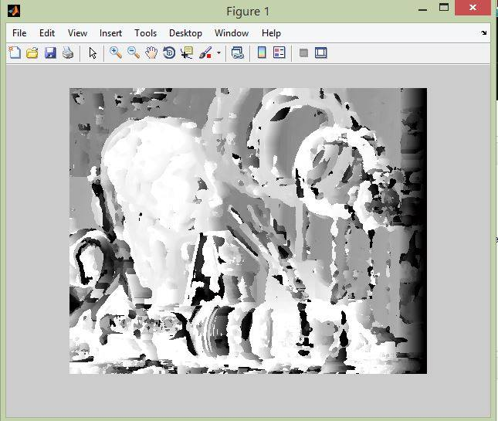 **For Image Right to Left**

With the color outputs the result looks like:

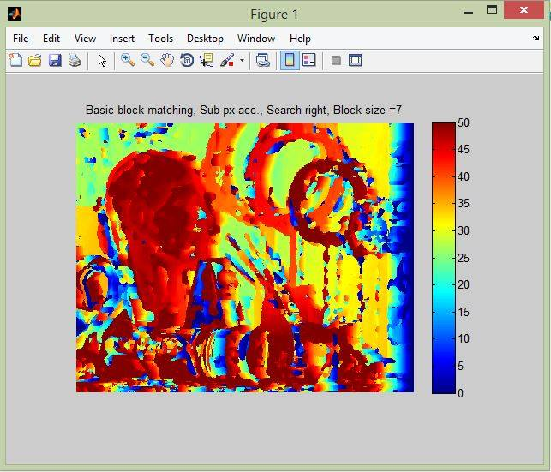

The MSE error has the same code and can output error for either the right or left input image depending on which one is in the input. For the right image the output I got for MSE Error was:

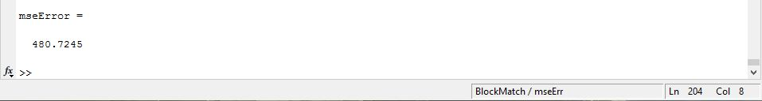

The consistency check gave me the following output:

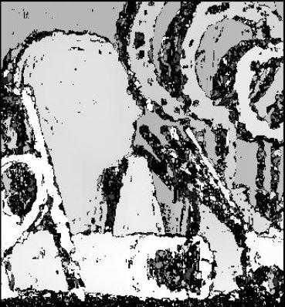

For the part 2:

The output from Dynamic Programming was similar to the block match, just faster.

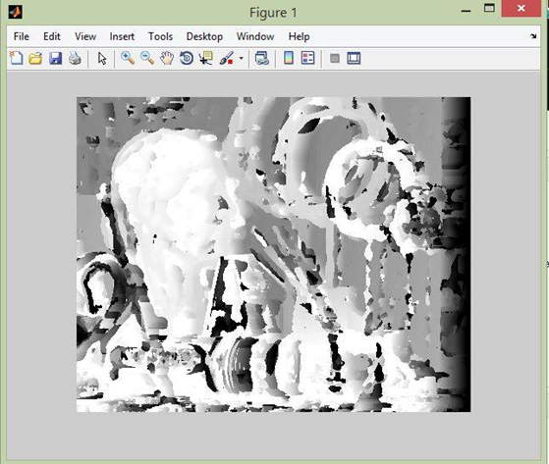

For the part 3:

The shifted images are:

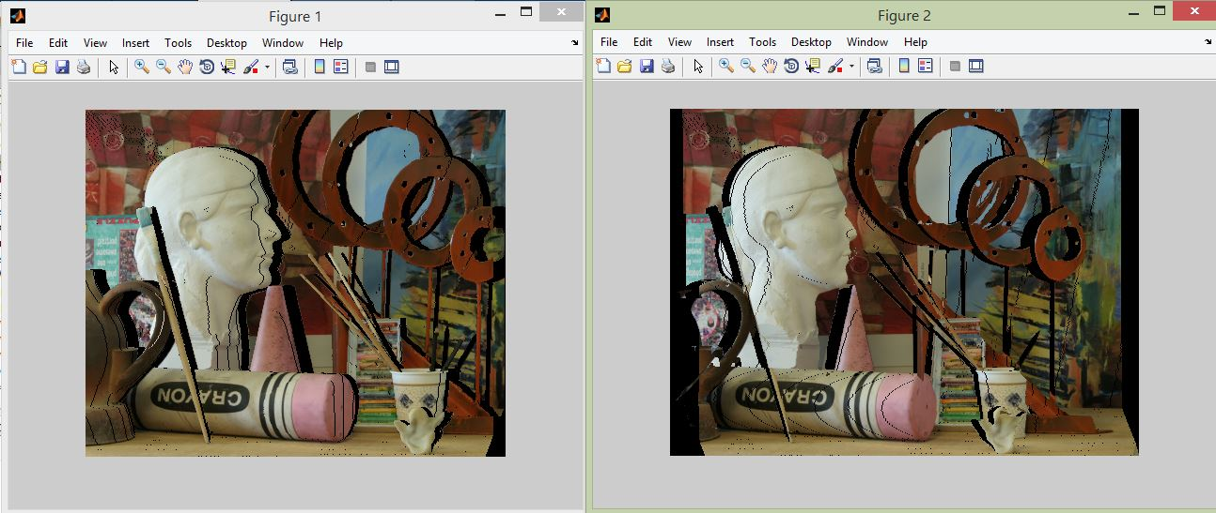

The final interpolated output was:

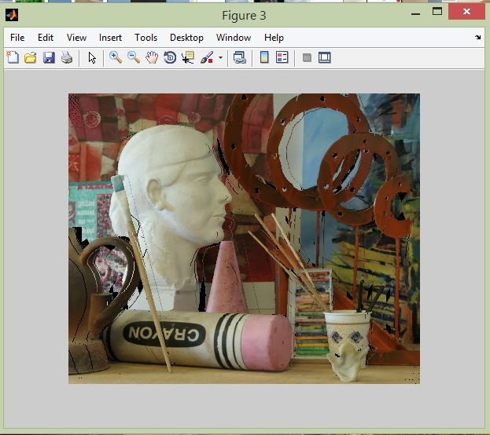

For the other images I had to change the window size because the looping was directly affected by it.

1. Window Based Matching (another option is to use active sensors)

To improve the window based matching:

• The similarity constraint is local (each reference window is matched independently)

• Need to enforce non-local correspondence constraints

1. The graph is as follows:
2. I used functions like min, max sum and mean etc. which helped me in avoiding loops for the dependent parts.
3. Using the number of loops present, the estimated runtimes are as follows:

Basic runtime for block matching: Polynomial O(n^5/n^6)

For Dynamic Programming: Polynomial O(n^3)

Run time increases with image size but decreases with window size.

A couple other algorithms are Image triangulation, TSGO, JSOSP+GCP